**Chapter 1**

**INTRODUCTION**

* 1. **A Brief Introduction**

**RADAR** is an object detection system which uses [radio waves](http://en.wikipedia.org/wiki/Radio_waves) to determine the range, altitude, direction, or speed of objects. Radar systems come in a variety of sizes and have different performance specifications. Some radar systems are used for air-traffic control at airports and others are used for long range surveillance and early-warning systems. A radar system is the heart of a missile guidance system. Small portable radar systems that can be maintained and operated by one person are available as well as systems that occupy several large rooms.

Radar was secretly developed by several nations before and during [World War II](http://en.wikipedia.org/wiki/World_War_II). The term RADAR itself, not the actual development, was coined in 1940 by the [United States Navy](http://en.wikipedia.org/wiki/United_States_Navy) as an [acronym](http://en.wikipedia.org/wiki/Acronym_and_initialism) for radio Detection and Ranging. The term radar has since entered [English](http://en.wikipedia.org/wiki/English_language) and other languages as the common noun radar, losing all capitalization.

The modern uses of radar are highly diverse, including air traffic control, [radar astronomy](http://en.wikipedia.org/wiki/Radar_astronomy), [air-defense systems](http://en.wikipedia.org/wiki/Antiaircraft_warfare), [antimissile systems](http://en.wikipedia.org/wiki/Close-in_weapon_system); [marine radars](http://en.wikipedia.org/wiki/Marine_radar) to locate landmarks and other ships; aircraft anti-collision systems; [ocean surveillance](http://en.wikipedia.org/wiki/Research_vessel) systems, outer space surveillance and [rendezvous](http://en.wikipedia.org/wiki/Space_rendezvous) systems; [meteorological](http://en.wikipedia.org/wiki/Meteorology) precipitation monitoring; altimetry and [flight control systems](http://en.wikipedia.org/wiki/Flight_control_system); [guided missile](http://en.wikipedia.org/wiki/Precision-guided_munition) target locating systems; and [ground-penetrating radar](http://en.wikipedia.org/wiki/Ground-penetrating_radar) for geological observations. High tech radar systems are associated with [digital signal processing](http://en.wikipedia.org/wiki/Digital_signal_processing) and are capable of extracting useful information from very high [noise](http://en.wikipedia.org/wiki/Noise_(electronics)) levels.

* 1. **Organization of the Report**

The report is divided into four chapters. Chapter 1 gives a brief introduction of the project covered. It contains the basics of a RADAR and the other tools and components used for completion of this project.

Chapter 2 aims at the literature survey of the project consisting of the basic idea of the project, and how we got the idea to make this project, all the help like websites, journals etc.

Chapter 3 covers the list of the components used in the projects and how to use them.

Chapter 4 covers the implementation of the project like boot loading to make own Arduino board, software used and the problems faced during the course of action.

Finally, Chapter 5 deals with the present as well as the future scope of the project, like how we can make use of this project for the betterment of the mankind.

**Chapter 2**

**LITERATURE SURVEY**

**2.1 ‘The Idea’**

Army, Navy and the Air Force make use of this technology. The use of such technology has been seen recently in the self parking car systems launched by AUDI, FORD etc. And even the upcoming driverless cars by Google like Prius and Lexus.

The project made by us can be used in any systems the customer may want to use like in a car, a bicycle or anything else. The use of Arduino [1] in the project provides even more flexibility of usage of the above-said module according to the requirements.

The idea of making an Ultrasonic RADAR came as a part of a study carried out on the working and mechanism of “Automobiles of Future”. Also, being students of ECE, we have always been curious about the latest ongoing technology in the world like Arduino, Raspberry Pi, Beagle-Bone boards etc. An hence this time we were able to get a hold of one of the Arduino boards, Arduino UNO R3. So, knowing about the power and vast processing capabilities of the Arduino, we thought of making it big and a day to day application specific module that can be used and configured easily at any place and by anyone.

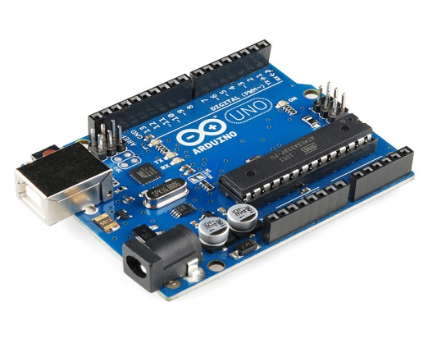 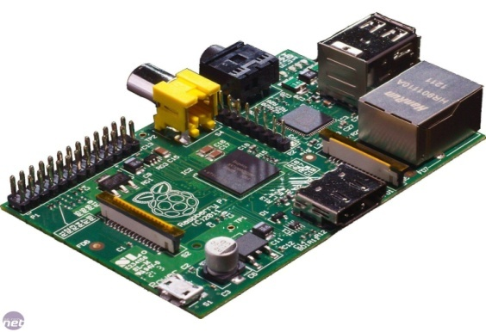

**Figure 2.1** Arduino UNO R3 and Raspberry Pi boards [1]

Moreover, in this fast moving world there is an immense need for the tools that can be used for the betterment of the mankind rather than devastating their lives. Hence, we decided to make some of the changes and taking the advantage of the processing capabilities of Arduino [1], we decided to make up the module more application specific.

Hence, from the idea of the self driving cars came the idea of self parking cars. The main problem of the people in India and even most of the countries is safety while driving. So, we came up with a solution to that by making use of this project to continuously scan the area for traffic, population etc. and as well as protection of the vehicles at the same time to prevent accidents or minor scratches to the vehicles.

**Chapter 3**

**INTRODUCTION TO THE COMPONENTS USED**

**3.1 Introduction to Arduino Uno**

The Arduino Uno is a microcontroller board based on the ATmega328. It has 14 digital Input /Output pins (of which 6 can be used as PWM outputs), 6 analog inputs, a 16MHz ceramic resonator, USB connection, a power jack, an ICSP header and a reset button. It contains everything needed to support the microcontroller; simply connect it to computer with a USB cable or power it with a AC-to-DC adapter or battery to get started. The Uno differs from all preceding boards in that it does not use the FTDI USB-to-serial driver chip. Instead, it features the Atmega16U2 programmed as a USB-to-serial converter. Changes in Uno R3[4]

1. Pin out: added SDA and SCL pins that are near to the AREF pin and two other new pins placed near to the reset pin, the IOREF that allow the shields to adapt to the voltage provided from the board. In future, shields will be compatible with both the board that uses the AVR, which operates with 5v and with the Arduino due that operates with 3.3v.
2. Stronger RESET circuit.
3. ATmega16U2 replace the 8U2.

"Uno" means one in Italian and is named to mark the upcoming release of Arduino 1.0. The Uno and version 1.0 will be the reference versions of Arduino, moving forward. The Uno is the latest in a series of USB Arduino boards, and the reference model for the Arduino platform; for a comparison with previous versions, see the index of Arduino Boards.

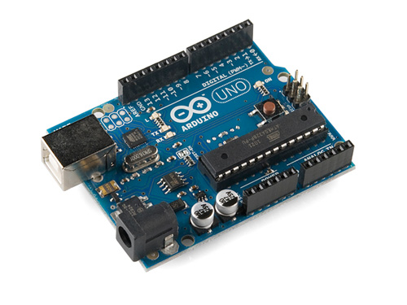

**Figure 3.1** Arduino UNO R3 Board [2]

**Table 3.1** Features of Arduino at a Glance

|  |  |
| --- | --- |
| **Microcontroller** | ATmega328 |
| **Operating Voltage** | 5V |
| **Input Voltage (recommended)** | 7-12V |
| **Input Voltage (limits)** | 6-20V |
| **Digital I/O Pins** | 14 (of which 6 provide PWM output) |
| **Analog Input Pins** | 6 |
| **DC Current per I/O Pin** | 40 mA |
| **DC Current for 3.3V Pin** | 50 mA |
| **Flash Memory** | 32 KB (ATmega328) of which 0.5 KB used by bootloader |
| **SRAM** | 2 KB (ATmega328) |
| **EEPROM** | 1 KB (ATmega328) |
| **Clock Speed** | 16 MHz |

**3.2 AVR ATmega328**

The ATmega328 is a single [chip](http://en.wikipedia.org/wiki/Integrated_circuits) [micro-controller](http://en.wikipedia.org/wiki/Micro-controller) created by [Atmel](http://en.wikipedia.org/wiki/Atmel) and belongs to the [mega AVR](http://en.wikipedia.org/wiki/MegaAVR) series. The high-performance Atmel [8-bit](http://en.wikipedia.org/wiki/8-bit) [AVR](http://en.wikipedia.org/wiki/Atmel_AVR) [RISC](http://en.wikipedia.org/wiki/RISC)-based microcontroller combines 32 KB [ISP](http://en.wikipedia.org/wiki/In-system_programming) [flash](http://en.wikipedia.org/wiki/Flash_memory) memory with read-while-write capabilities, 1 KB [EEPROM](http://en.wikipedia.org/wiki/EEPROM), 2 KB [SRAM](http://en.wikipedia.org/wiki/Static_random-access_memory), 23 general purpose I/O lines, 32 general purpose working [registers](http://en.wikipedia.org/wiki/Processor_register), three flexible timer/[counters](http://en.wikipedia.org/wiki/Counters) with compare modes, internal and external [interrupts](http://en.wikipedia.org/wiki/Interrupts), serial programmable [usart](http://en.wikipedia.org/wiki/USART), a byte-oriented 2-wire serial interface, [spi](http://en.wikipedia.org/wiki/Serial_Peripheral_Interface_Bus) serial-port, a 6-channel 10 bit Analog to Digital converter (8-channels)in [tqfp](http://en.wikipedia.org/wiki/TQFP) and [qfn](http://en.wikipedia.org/wiki/QFN)/[mlf](http://en.wikipedia.org/wiki/Quad-flat_no-leads_package#Variants) packages),programmable watchdog timer with internal oscillator and five software selectable power saving modes. The device operates between 1.8-5.5 volts. By executing powerful instructions in a single clock cycle, the device achieves throughputs approaching 1 [MIPS](http://en.wikipedia.org/wiki/Million_instructions_per_second#Million_instructions_per_second) per MHz, balancing power consumption and processing speed.[5]

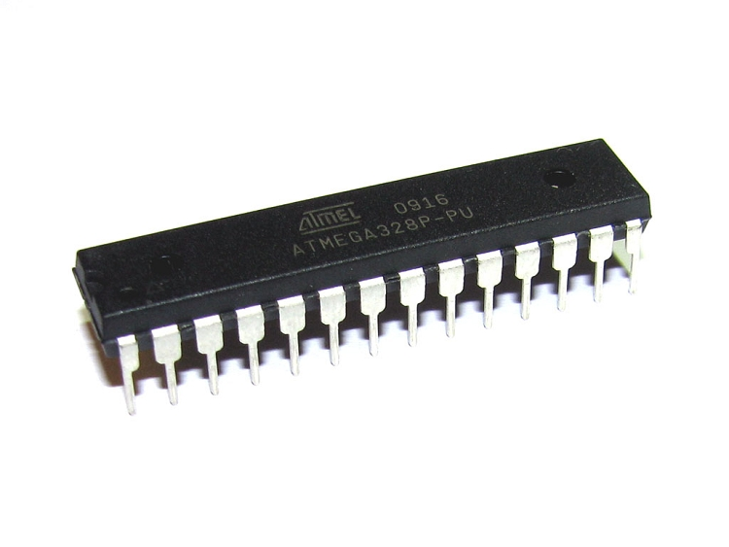

**Figure 3.2** ATmega328 [3]

**3.3 Crystal Oscillator**

A crystal oscillator is an [electronic oscillator](http://en.wikipedia.org/wiki/Electronic_oscillator) circuit that uses the mechanical [resonance](http://en.wikipedia.org/wiki/Resonance) of a vibrating [crystal](http://en.wikipedia.org/wiki/Crystal) of [piezoelectric material](http://en.wikipedia.org/wiki/Piezoelectricity#Materials) to create an electrical signal with a very precise [frequency](http://en.wikipedia.org/wiki/Frequency). This frequency is commonly used to keep track of time (as in [quartz wristwatches](http://en.wikipedia.org/wiki/Quartz_clock)), to provide a stable [clock signal](http://en.wikipedia.org/wiki/Clock_signal) for [digital](http://en.wikipedia.org/wiki/Digital_data) [integrated circuits](http://en.wikipedia.org/wiki/Integrated_circuits), and to stabilize frequencies for [radio transmitters](http://en.wikipedia.org/wiki/Radio_transmitter) and [receivers](http://en.wikipedia.org/wiki/Radio_receiver). The most common type of piezoelectric resonator used is the [quartz](http://en.wikipedia.org/wiki/Quartz) crystal, so oscillator circuits incorporating them became known as crystal oscillators,but other piezoelectric materials including polycrystalline ceramics are used in similar circuits.

Quartz crystals are manufactured for frequencies from a few tens of [kilohertz](http://en.wikipedia.org/wiki/Kilohertz) to hundreds of megahertz. More than two billion crystals are manufactured annually. Most are used for consumer devices such as [wristwatches](http://en.wikipedia.org/wiki/Wristwatch), [clocks](http://en.wikipedia.org/wiki/Clock), [radios](http://en.wikipedia.org/wiki/Radio), [computers](http://en.wikipedia.org/wiki/Computer), and [cell phones](http://en.wikipedia.org/wiki/Cellphone). Quartz crystals are also found inside test and measurement equipment, such as counters, [signal generators](http://en.wikipedia.org/wiki/Signal_generator), and [oscilloscopes](http://en.wikipedia.org/wiki/Oscilloscope).

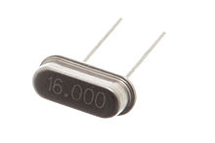

**Figure 3.3** Crystal Oscillator (16 MHz) [4]

**3.4 Servo Motor**

A servomotor is a [rotary actuator](http://en.wikipedia.org/wiki/Rotary_actuator) that allows for precise control of angular position, velocity and acceleration. It consists of a suitable motor coupled to a sensor for position feedback. It also requires a relatively sophisticated controller, often a dedicated module designed specifically for use with servomotors.

Servomotors are not a different class of motor, on the basis of fundamental operating principle, but uses [servomechanism](http://en.wikipedia.org/wiki/Servomechanism) to achieve closed loop control with a generic open loop motor.

Servomotors are used in applications such as [robotics](http://en.wikipedia.org/wiki/Robotics), [CNC](http://en.wikipedia.org/wiki/CNC) machinery or automated manufacturing.

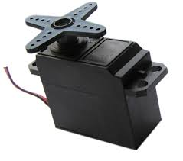

**Figure 3.4** Servo Motor [5]

**3.5 Voltage Regulator**

**A voltage regulator is an electrical regulator designed to automatically maintain a constant voltage level.**

**With the exception of shunt regulators, all modern electronic voltage regulators operate by comparing the actual output voltage to some internal fixed reference voltage. Any difference is amplified and used to control the regulation element. This forms a negative feedback servo control loop. If the output voltage is too low, the regulation element is commanded to produce a higher voltage**

**The 78XX series of three-terminal positive regulator are available in the TO-220/D-PAK package and with several fixed output voltages, making them useful in a wide range of applications. Each type employs internal current limiting, thermal shut down and safe operating area protection, making it essentially indestructible. If adequate heat sinking is provided, they can deliver over 1A output current. Although designed primarily as fixed voltage regulators, these devices can be used with external components to obtain adjustable voltages and currents. [6]**

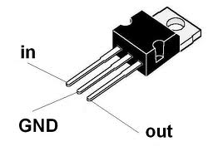

**Figure 3.5** Voltage Regulator (7805) [6]

**3.6 Ultrasonic Sensor**

Ultrasonic sensors [7] (also known as transceivers when they both send and receive, but more generally called transducers) work on a principle similar to [radar](http://en.wikipedia.org/wiki/Radar) or [sonar](http://en.wikipedia.org/wiki/Sonar) which evaluate attributes of a target by interpreting the echoes from radio or sound waves respectively. Ultrasonic sensors generate high frequency sound waves and evaluate the echo which is received back by the sensor. Sensors calculate the time interval between sending the signal and receiving the echo to determine the distance to an object.

This technology can be used for measuring wind speed and direction ([anemometer](http://en.wikipedia.org/wiki/Anemometer)), tank or channel level, and speed through air or water. For measuring speed or direction a device uses multiple detectors and calculates the speed from the relative distances to particulates in the air or water. To measure tank or channel level, the sensor measures the distance to the surface of the fluid. Further applications include: [humidifiers](http://en.wikipedia.org/wiki/Humidifier), [sonar](http://en.wikipedia.org/wiki/Sonar), [medical ultra sonography](http://en.wikipedia.org/wiki/Medical_ultrasonography), [burglar alarms](http://en.wikipedia.org/wiki/Burglar_alarms) and [non-destructive testing](http://en.wikipedia.org/wiki/Non-destructive_testing).

Systems typically use a transducer which generates sound waves in the ultrasonic range, above 18,000 hertz, by turning electrical energy into sound, then upon receiving the echo turn the sound waves into electrical energy which can be measured and displayed.

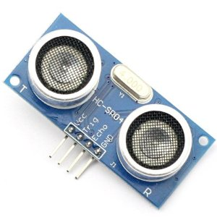

**Figure 3.6 Ultrasonic Sensor** [7]

**Chapter 4**

**PRACTICAL IMPLEMENTATION**

**4.1 Making own Arduino Uno Board/Boot Loading the ATmega328**

Since, we believe in learning by doing. So, we decided to make our own arduino board instead of using the readymade board. So, the steps required to make an arduino board [8] are as follows:

* 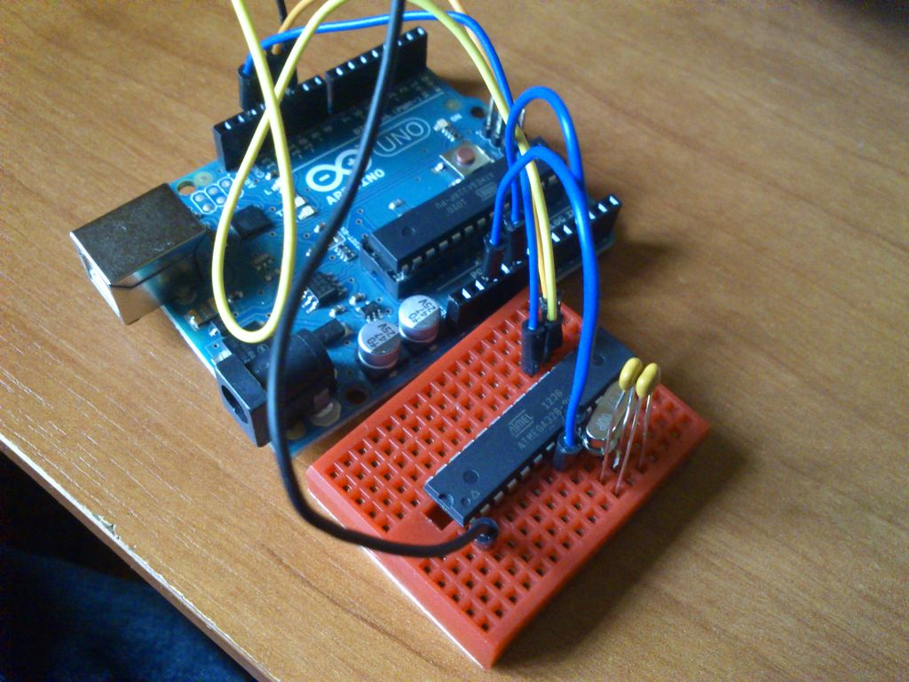Boot loading an Atmega328 using the Arduino board by uploading the boot loader program to the Microcontroller.

**Figure 4.1** Boot loading Atmega328 using Arduino Uno [8]

* Making the connections on a general purpose PCB, connecting the crystal osicillator, capacitors, connectors for the connections to Arduino board etc.
* Providing the power supply, usually 5 volts.
* 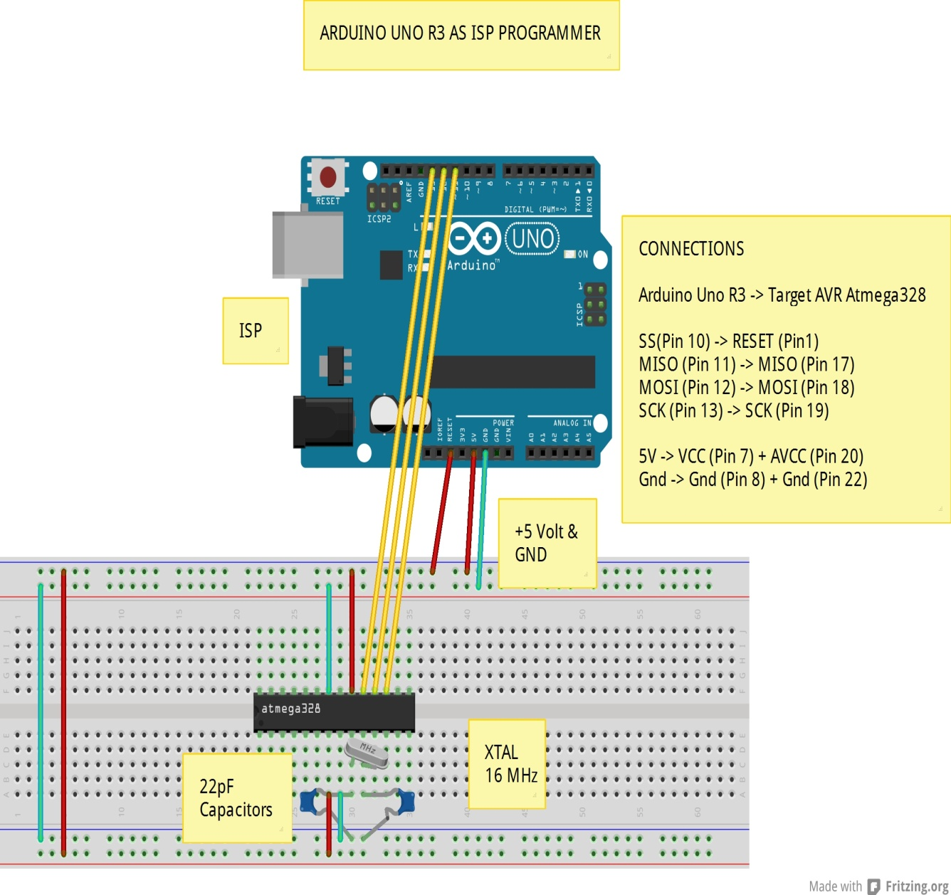Arduino is ready for use.

**Figure 4.2** Circuit diagram for Boot Loading ATmeg328

After you have done all this, then only the minimum circuitry like crystal oscillator, capacitors, connectors, power supply is required to complete the board. The same circuit can be made on the PCB, either designed or general purpose. Since, Arduino is an Open-Source. Hence, it is easy to make and can have any enhancements as per the requirements.

**4.2 Connecting the Servo Motor**

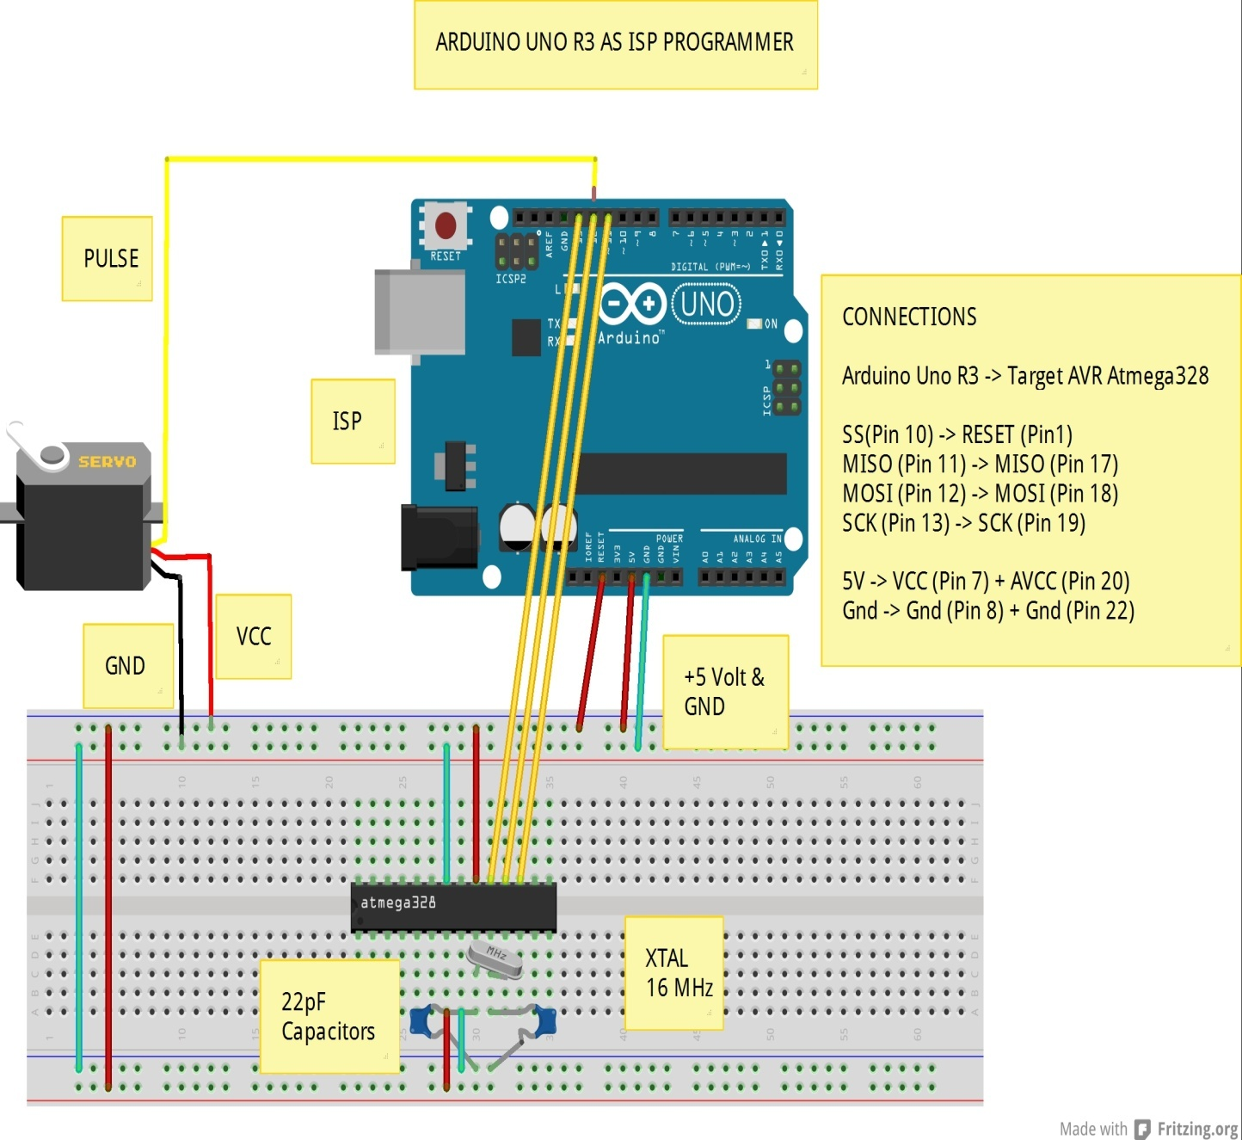

**Figure 4.3** Connecting the Servo Motor

A servomotor is a [rotary actuator](http://en.wikipedia.org/wiki/Rotary_actuator) that allows for precise control of angular position, velocity and acceleration.

A normal servo motor has three terminals:

1.VCC

2. GND

3. PULSE

A servo motor works at normally 4.8 to 6 volts. Gnd is provided by connecting it to the Ground of the Arduino. The total time for a servo motor pulse is usually 20ms. To move it to one end of say 0 degree angle, a 1ms pulse is used and to move it to other end i.e 180 degree, a 2ms pulse is applied. Hence, according to this to move the axis of the servo motor to the center, a pulse of time 1.5 ms should be applied. For this, the pulse wire of the servo motor is connected to the Arduino that provides the digital pulses for pulse width modulation of the pulse. Hence, by programming for a particular pulse interval the servo motor can be controlled easily.

**4.3 Connecting the Ultrasonic Sensor**

An Ultrasonic Sensor consists of three wires. One for Vcc, second for Gnd and the third for pulse signal. The ultrasonic sensor is mounted on the servo motor and both of them further connected to the Arduino board. The ultrasonic sensor uses the reflection principle for its working. When connected to the Arduino, the arduino provides the pulse signal to the ultrasonic sensor which then sends the ultrasonic wave in forward direction. Hence, whenever there is any obstacle detected or present in front, it reflects the waves which are received by the ultrasonic sensor. If detected, the signal is sent to the arduino and hence to the PC/laptop to the processing software that shows the presence of the obstacle on the rotating RADAR screen with distance and the angle at which it has been detected.

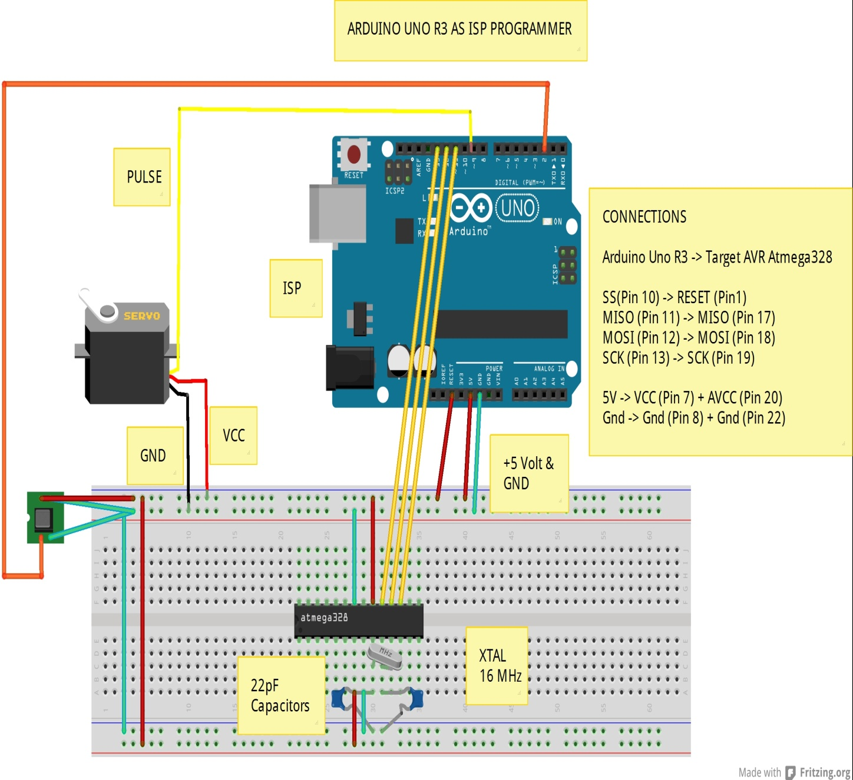

**Figure 4.4:** Connecting Ultrasonic Sensor to Arduino

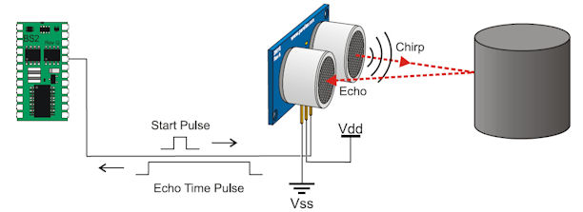

**Figure 4.5** Working of Ultrasonic Sensor

**4.4 Using the Arduino IDE**

The Arduino [integrated development environment](http://en.wikipedia.org/wiki/Integrated_development_environment) (IDE) is a [cross-platform](http://en.wikipedia.org/wiki/Cross-platform) application written in [Java](http://en.wikipedia.org/wiki/Java_(programming_language)), and is derived from the IDE for the [Processing programming language](http://en.wikipedia.org/wiki/Processing_(programming_language)) and the [Wiring](http://en.wikipedia.org/wiki/Wiring_(development_platform)) projects. It is designed to introduce programming to artists and other newcomers unfamiliar with software development. It includes a code editor with features such as [syntax highlighting](http://en.wikipedia.org/wiki/Syntax_highlighting), [brace matching](http://en.wikipedia.org/wiki/Brace_matching), and automatic indentation, and is also capable of compiling and uploading programs to the board with a single click. A program or code written for Arduino is called a "sketch".

Arduino programs are written in [C](http://en.wikipedia.org/wiki/C_(programming_language)) or [C++](http://en.wikipedia.org/wiki/C%2B%2B). The Arduino IDE comes with a [software library](http://en.wikipedia.org/wiki/Software_library) called "Wiring" from the original Wiring project, which makes many common input/output operations much easier. Users only need define two functions to make a run able [cyclic executive](http://en.wikipedia.org/wiki/Cyclic_executive) program:

* Setup(): a function run once at the start of a program that can initialize settings
* Loop(): a function called repeatedly until the board powers off.

Open the Arduino IDE software and select the board in use. To select the board:

* Go to Tools.
* Select Board.
* Under board, select the board being used, in this case Arduino Uno.
* Go to Tools and to Port and select the port at which the arduino board is connected.

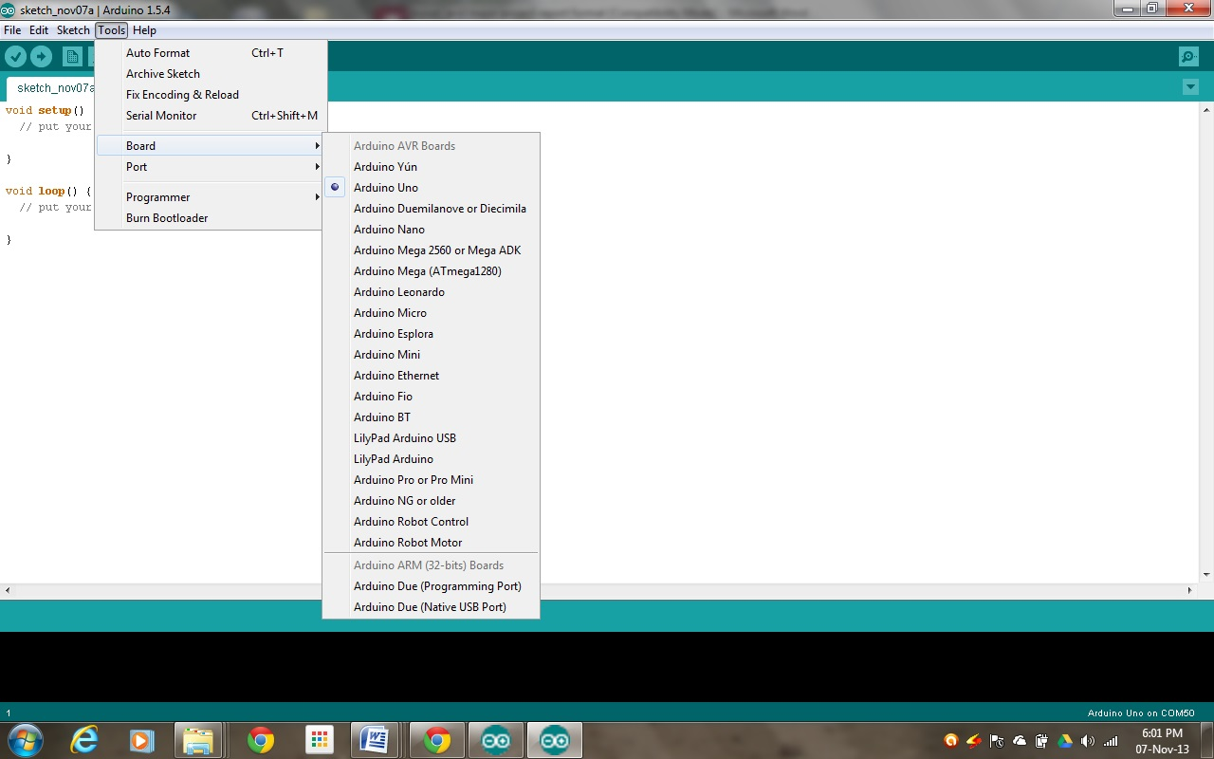

**Figure 4.6** Selecting the Board in Arduino IDE

Write the code in the space provided and click on compile. Once the code is compiled, click on upload to upload the sketch to the Arduino board.

**4.5 Using the Processing Software**

Processing is an [open source](http://en.wikipedia.org/wiki/Open-source_software) [programming language](http://en.wikipedia.org/wiki/Programming_language) and [integrated development environment](http://en.wikipedia.org/wiki/Integrated_development_environment) (IDE) built for the electronic arts, [new media art](http://en.wikipedia.org/wiki/New_media_art), and [visual design](http://en.wikipedia.org/wiki/Visual_design) communities with the purpose of teaching the fundamentals of [computer programming](http://en.wikipedia.org/wiki/Computer_programming) in a visual context, and to serve as the foundation for electronic sketchbooks. The project was initiated in 2001 by [Casey Reas](http://en.wikipedia.org/wiki/C.E.B._Reas) and [Benjamin Fry](http://en.wikipedia.org/wiki/Benjamin_Fry), both formerly of the Aesthetics and Computation Group at the [MIT Media Lab](http://en.wikipedia.org/wiki/MIT_Media_Lab). One of the stated aims of Processing is to act as a tool to get non-programmers started with programming, through the instant gratification of visual feedback. The language builds on the [Java language](http://en.wikipedia.org/wiki/Java_(programming_language)), but uses a simplified syntax and graphics programming model.

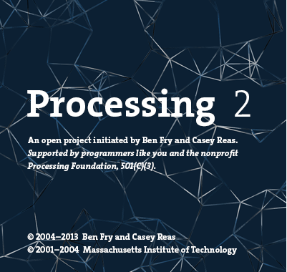

**Figure 4.7** Processing Software (Version 2.0)

* 1. **Problems Faced**

Since, electronic components when used to form any circuit require some amount of troubleshooting to make the circuit work according to our expectations. In our project, there were some problems that we had to deal with.

* + 1. **Making own Arduino board**

The Arduino boards are available readily in the electronics market, but we decided to make our own Arduino board instead of buying one. So, the first problem was where to start from to achieve this goal. Since, all parts on an arduino board are SMD’s, so we had to find a way to replace the SMD’s with DIP IC’s and also had to make an AVR programmer in order to pursue our further work. Hence, it took us some days to determine and plan our course of action.

After that we had to boot load the AVR chip so as to make it compatible with the Arduino IDE software. Hence, we had to find a way to boot load the Arduino using the AVR programmer. It took us a long time to make the AVR programmer by researching on the type of communication and architecture of the AVR as it is not as same as a 8051 microcontroller.

* + 1. **Communicating with Arduino through PC**

Another major problem related to the Arduino board was the communication with it from PC. Since, we require RS-232 to TTL conversion for the communication, so we tried some methods:

* 1. Firstly we used the MAX-232 IC to communicate with the Arduino as with the 8051 but due to large voltage drop and mismatch in the speed, it failed to communicate.
  2. Next, we tried to use a dedicated AVR as USB to Serial converter as in the original arduino board, the difference being DIP AVR used by us instead of the SMD Mega16U2 controller. But, unfortunately we were unable to communicate through it.
  3. At last we had no other choice but to complete the project in time by using the FTDI FT-232R chip for USB to Serial conversion. Finally IT WORKED!!!
     1. **Programming the Arduino to display the RADAR screen**

The next part of the project was to be able to display the RADAR screen. For this we used VB.NET to form the RADAR screen but interfacing it with the Arduino input was a little bit of a problem and not synchronized with the Arduino input. After a lot of trials, we came to know about the Processing software (Version 2.0). So, we had to go through a lot of programs to finally program it to form the RADAR screen.

**Chapter 5**

**PRESENT AND FUTURE SCOPE OF PROJECT**

The idea of making an Ultrasonic RADAR appeared to us while viewing the technology used in defense, be it Army, Navy or Air Force and now even used in the automobiles employing features like automatic/driverless parking systems, accident prevention during driving etc. The applications of such have been seen recently in the self parking car systems launched by AUDI, FORD etc. And even the upcoming driverless cars by Google like Prius and Lexus.

The project made by us can be used in any systems you may want to use like in a car, a bicycle or anything else. The use of Arduino in the project provides the flexibility of usage of the above-said module according to the requirements.

**Figure 5.1** Driverless Car by “GOOGLE” [9]

* 1. **Applications in Air Force**

In [aviation](http://en.wikipedia.org/wiki/Aviation), aircraft are equipped with radar devices that warn of aircraft or other obstacles in or approaching their path, display weather information, and give accurate altitude readings. The first commercial device fitted to aircraft was a 1938 Bell Lab unit on some [United Air Lines](http://en.wikipedia.org/wiki/United_Air_Lines) aircraft. Such aircraft can land in fog at airports equipped with radar-assisted [ground-controlled approach](http://en.wikipedia.org/wiki/Ground-controlled_approach) systems in which the plane's flight is observed on radar screens while operators radio landing directions to the pilot.

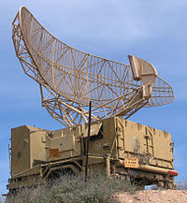 [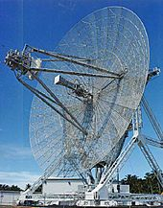](http://www.google.co.in/imgres?sa=X&biw=1280&bih=698&tbm=isch&tbnid=J5EEms3Gcs-dAM:&imgrefurl=http://en.wikipedia.org/wiki/Radar&docid=a4w7RGyvDhQzcM&imgurl=http://upload.wikimedia.org/wikipedia/commons/9/90/Radar_antenna.jpg&w=546&h=697&ei=wuuKUs2NIMjZrQf)

**Figure 5.2** Air Force Applications [10]

**5.2 Naval Applications**

[Marine radars](http://en.wikipedia.org/wiki/Marine_radar) are used to measure the bearing and distance of ships to prevent collision with other ships, to navigate, and to fix their position at sea when within range of shore or other fixed references such as islands, buoys, and lightships. In port or in harbor, [vessel traffic service](http://en.wikipedia.org/wiki/Vessel_traffic_service) radar systems are used to monitor and regulate ship movements in busy waters.

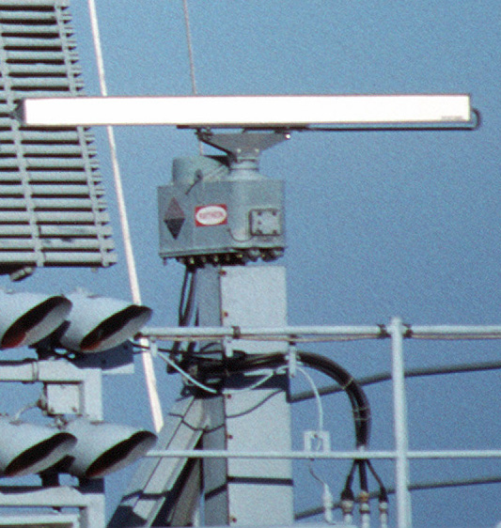

**Figure 5.3** Naval Applications [11]

**5.3 Applications in Army**

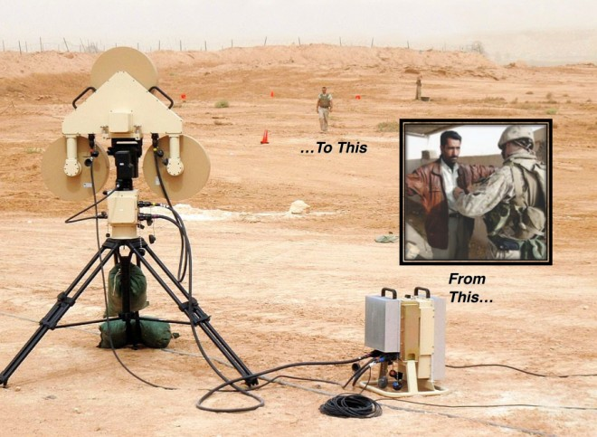

# Figure 5.4 Army Using Radar to Spot Suicide Bombers From100 Yards [12]

Two video cameras automatically detect and track individuals walking anywhere near the system, within the range of a soccer field. Low-level radar beams are aimed at them and then reflected back to a computer, which analyzes the signals in a series of algorithms. It does this by comparing the radar return signal (which emits less than a cell phone) to an extensive library of “normal responses.” Those responses are modeled after people of all different shapes and sizes (SET [got around to adding females in 2009](http://www.army.mil/article/31530/counter-bomber-test-helps-washington)). It then compares the signal to another set of “anomalous responses” – any anomaly, and horns go off. Literally, when the computer detects a threat, it shows a red symbol and sounds a horn. No threat and the symbol turns green, greeting the operators with a pleasant piano riff.

**5.4 Meteorological Applications**

Meteorologists [13] use radar to monitor [precipitation](http://en.wikipedia.org/wiki/Precipitation_(meteorology)) and wind. It has become the primary tool for short-term [weather forecasting](http://en.wikipedia.org/wiki/Weather_forecast) and watching for [severe weather](http://en.wikipedia.org/wiki/Severe_weather) such as [thunderstorms](http://en.wikipedia.org/wiki/Thunderstorm), [tornadoes](http://en.wikipedia.org/wiki/Tornado), [winter storms](http://en.wikipedia.org/wiki/Winter_storm), precipitation types, etc. [Geologists](http://en.wikipedia.org/wiki/Geologist) use specialized [ground-penetrating radars](http://en.wikipedia.org/wiki/Ground-penetrating_radar) to map the composition of [Earth's crust](http://en.wikipedia.org/wiki/Crust_(geology)).

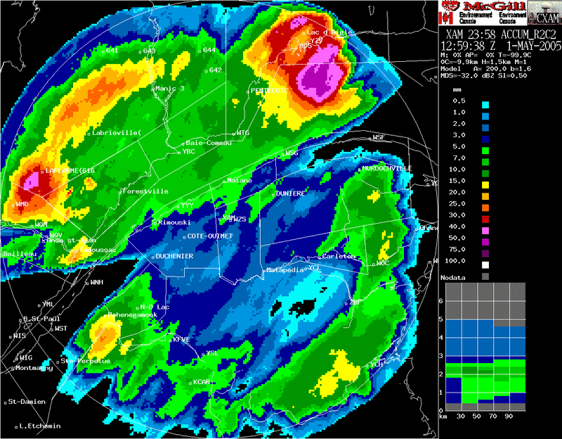

**Figure 5.5** Weather RADAR [13]

**A LOOK AT THE FINAL PROJECT**

ig. Final Project

Fig. RADAR Screen

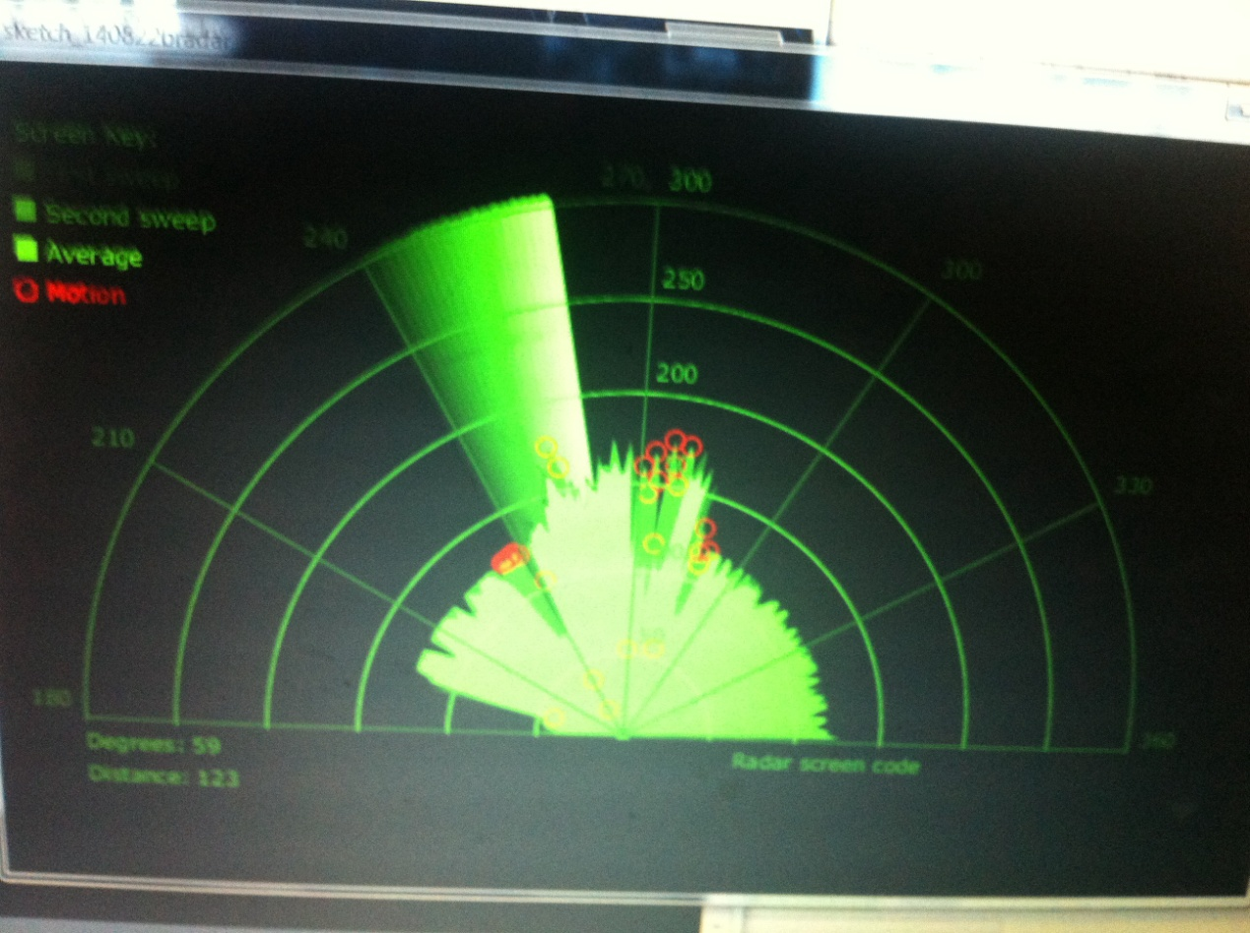

**REFERENCES**

[1] <http://www.arduino.cc/>

[2] http://www.arduinoproducts .cc/

[3] <http://www.atmel.com/atmega328/>

[4] <http://en.wikipedia.org/wiki/File:16MHZ_Crystal.jpg>

[5]http://www.google.co.in/imgres?imgurl=http://www.electrosome.com/wp- content/uploads/2012/06/ServoMotor.gif&imgrefurl=http://www.electrosome.com/tag/servomotor/&h=405&w=458&sz=67&tbnid=rcdlwDVt_x0DdM:&tbnh=100&tbnw=113&zoom=1&usg=__6J2h0ZocdoSMrS1qgK1I2qpTQSI=&docid=lEfbDrEzDBfzbM&sa=X&ei=a_OKUvTbD8O5rgeYv4DoDQ&ved=0CDwQ9QE

[6] http//:www.sproboticworks.com/ic%20pin%20configuration/7805/Pinout.jpg/

[7] [http://www.sproboticworks.com/ic%ultrasonicsensor%20pinout.jpg](http://www.sproboticworks.com/ic%25ultrasonicsensor%20pinout.jpg)

[8] [http://www.instructables.com/id/ ATMega328-using-Arduino-/](http://www.instructables.com/id/%20ATMega328-using-Arduino-/)

[9] <http://www.motherjones.com/files/blog_google_driverless_car.jpg>

[10] [http://www.google.co.in/imgres/Radar_antenna.jpg&w=546&h=697&ei=wuuK](http://www.google.co.in/imgres/Radar_antenna.jpg&w=546&h=697&ei=wuuKU)

[11] <http://www.radomes.org/museum/photos/equip/ANSPS17.jpg>

[12] [http://www.wired.com/dangerroom/2011/07/ suicide-bombers-from-100-yards/](http://www.wired.com/dangerroom/2011/07/%20suicide-bombers-from-100-yards/)

[13] <http://upload.wikimedia.org/wikipedia/commons/Radaraccumulationseng.png>

[14] <http://arduino.cc/en/Tutorial/BarGraph/>

[15] <http://arduino.cc/en/Tutorial/LiquidCrystal/>

[16] <http://fritzing.org/>